Service Description (SD) - Producer

**Abstract**

This document defines the template for the Service Description of Arrowhead compliant Services.

A Service Description provides an abstract description of what is needed for systems /devices/units/software to provide and/or consume a specific service.

SD’s for Application Services are created (specified) by the Pilots WP’s and by the common Arrowhead framework. The SD shall make it possible for an engineer with technical programming knowledge to achieve an Arrowhead compliant realization of a provider and/or consumer of description of how the service is implemented/realized by using the Communication Profile and the chosen technologies.

A Service Description (SD) is the Service in a specific technology. All systems / devices /units/software implementing an Interface Design Description which complies with this SD will be able to exchange information with each other.

All Arrowhead Service Description should be specified using this template and stored on a common repository (available on the SVN server), in order to document and formalize the pilot demonstrators and the common Arrowhead framework.

## Service Description Overview

This service provides random data for demo purposes.

## Abstract Interfaces

## REST Interface

This Demo Producer provides a REST interface for communication with a Consumer.

## Function

The function of this interface is to demonstrate that the orchestration between the Consumer and the Provider works.

## Sequence Diagrams

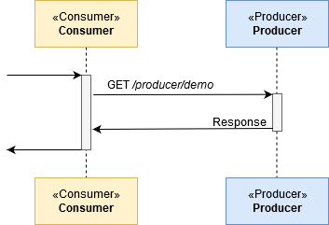

## Abstract Information Model

The output of the service is a *Response*.

**Table 1 Data type description**

|  |  |
| --- | --- |
| **Field** | **Description** |
| Timestamp | Timestamp of when the request was received and processed |
| Value | Random value between 0 and 100 |

1. Non-functional Requirements

This service have no Non-functional Requirements

## References

## Revision history

## Amendments

|  |  |  |  |  |
| --- | --- | --- | --- | --- |
| No. | Date | Version | Subject of Amendments | Author |
| 1 | 2020-12-10 | 0.1 | First Draft | Gustav Hansson |
| 2 |  |  |  |  |
| 3 |  |  |  |  |

## Quality Assurance

|  |  |  |  |
| --- | --- | --- | --- |
| No. | Date | Version | Approved by |
| 1 |  |  |  |
| 2 |  |  |  |